STRAWMAN LETTER

Dear Senator or _______:

Without question, the most serious economic and environmental threat to ever face this region is heading our way in the form of the invasive Silver Carp. They will destroy the fishery, ecology, recreation (they have broken jaws, fractured skulls, and knocked children out of boats—and are lethal), and the Economic Engine of Chickamauga, Watts Bar, Melton Hill, Fort Loudon, and Tellico Lakes if they are not stopped. The Land Between the Lakes (Kentucky and Barkley Lakes) and many others, are dealing with a destroyed fishery and recreation, and a >50% decline in the regional economic income due to the carp, and there is no possibility of recovery of those ecosystems.

If they reach us, based on data from a U.T study and TVA report of 2016, a 50% hit to the regional economy of our five beautiful lakes will be $1.3 Billion Annually—Yes Annually! These fish can be stopped by installing electric barriers at the Chickamauga lock, but it is absolutely imperative a project be implemented immediately, for it will take 2-3 years to complete. Please note, if a person fell into the water, electrocution is ‘impossible.’ The max voltage is 1.2V pulsed D.C. and 0.045 amps (4.5 mA). This isn’t even 10% of lethality, and there has never been a case of electrocution in water or in industry at such low current/V, and people have swum through this low level.

It is my understanding that the Senate Appropriations Committee has approved the Interior Appropriations Bill which included $25 million for the critically needed Asian Carp control. This is why I am writing to you. It appears the major portion of this money will be spent on attempting to reduce the populations of these fish in overrun lakes through subsidizing commercial fishing, researching population estimates, finding markets for the carp, etc. Last year alone they subsidized the removal of over two-million pounds of fish from Land Between the Lakes.

It is essential you understand removing fish will never alleviate the problem. One female typically lays four-million eggs; thus, the reduced population will quickly recover. Removing them only means slightly fewer fish are there to jump and hit someone, and the ecosystem is being destroyed at a slightly slower rate. Though that is a good thing, the money will award little if any long-term value. Too, it absolutely cannot compare to the MAJOR value gained if that money is utilized to PREVENT ecosystem, recreation, and economic destruction of five beautiful silver-carp free lakes in East Tennessee. We can “Prevent” what happened to The Land Between the Lakes from occurring here if federal funding is prioritized to PREVENT our lakes from destruction rather than merely putting a Band-Aid on destroyed lakes. The simplest “Formal Decision Analysis” will clearly select “Prevent Destruction” as the top priority for spending limited funds.

We feel for all those businesses and people impacted by this destructive invasive fish, but as well, they should be in favor of us not having to live with what they are forced to live with. They have to deal with the disease, but if that same disease can be prevented in five lakes, surely it takes precedence.

We are asking you to understand this dilemma and do what you can to see to it that our lakes are protected as a priority to spending those funds to try and help presently destroyed ecosystems. We must install an electric barrier at the Chickamauga Lock to prevent the disease from killing our five beautiful, economically thriving lakes. If you would like the environmental and economic science behind this situation, please contact Timothy Joseph, Chairman of the Watts Bar Ecology and Fishery Council (wbefc.org), an experienced PhD fishery biologist and expert in this field. Dr. Joseph will gladly present a science-based PowerPoint presentation to you covering every aspect of this most serious problem and how to fix it. He can be reached at timjosephphd@gmail.com or 865-354-6620.

Will you please help us?

Genuine Regards,

I received from the TWF following the Sept 26th conference call.
Listed are the Senators that should be contacted and sent a letter expressing YOUR concern on the allocation of the federal funds. Too, the letter should be sent to all local, state, county, and federal government officials representing this region. As well, you should let the TWF know you are concerned with how the funds will be allocated. Their priority is presently seriously misplaced, it must be changed. Our silver carp free lakes must take priority.
Thanks for your support,
Tim
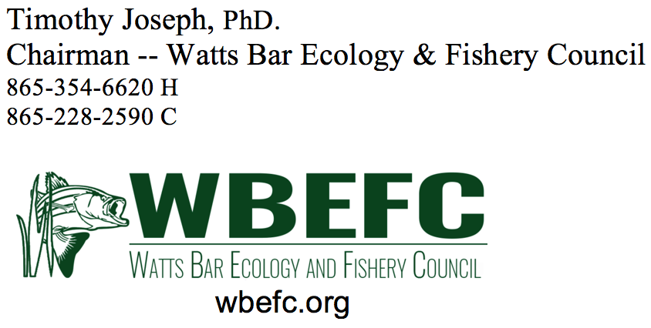
______________________________________
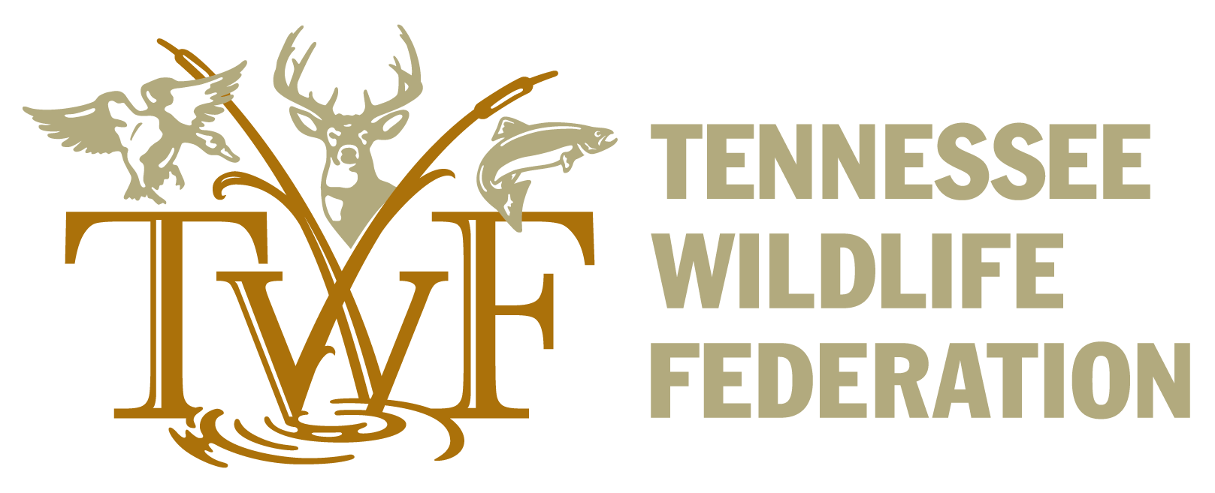

Lindsay Gardner | Conservation Policy Manager
Tennessee Wildlife Federation
Office: (615) 353-1133 | Cell: (615) 415-2873
www.tnwf.org

Thank you for your interest in combating Asian carp!
We had great attendance on yesterday’s call with nearly 50 people online.
Funding For Asian Carp Management and Control
We received important news yesterday that the full Senate Appropriations Committee approved the Interior Appropriations bill. It includes $25 million of critically-needed funding for Asian Carp management and control (including the Southeast). In particular, this budget money would benefit work in the Tennessee and Cumberland River Basins and existing programs at Lake Barkley, Kentucky Lake, in the Ohio River and beyond. This represents a $14M increase in Asian carp funding targeted specifically to our region.
Call to Action
Please thank Senator Alexander, Senator McConnell, Senator Shelby, and Senator Murkowski for their leadership and dedication in ensuring that $25M for Asian Carp management and control ($14M over the enacted amount) was included in the FY20 appropriations budget proposal. You can do so by calling and emailing their offices directly (refer to the numbers listed below).
Also, stay tuned as our next action will be in a few weeks when we will need your help to engage members of the House to show their support for the funds.
Senator Lamar Alexander – (202) 224-4944, https://www.alexander.senate.gov/public/index.cfm?p=Email
Senator Mitch McConnell - (202) 224-2541, https://www.mcconnell.senate.gov/public/index.cfm?p=ContactForm
Senator Richard Shelby - (202) 224-5744, https://www.shelby.senate.gov/public/index.cfm/emailsenatorshelby
Senator Lisa Murkowski - (202)-224-6665, https://www.murkowski.senate.gov/contact/email

